Kingdom of Saudi Arabia  Ministry of Education  Prince Sattam Bin Abdulaziz University  College of Computer  Engineering and sciences  Department of Computer Sciences |  | وزارة التعليم  جامعة الامير سطام بن عبد العزيز  كلية هندسة وعلوم الحاسب  قسم علوم الحاسب

CS 4831 - Mobile Application Development
Year 26-27 Sem1
Lab Exrecise 1
- Design the following constraint Layout
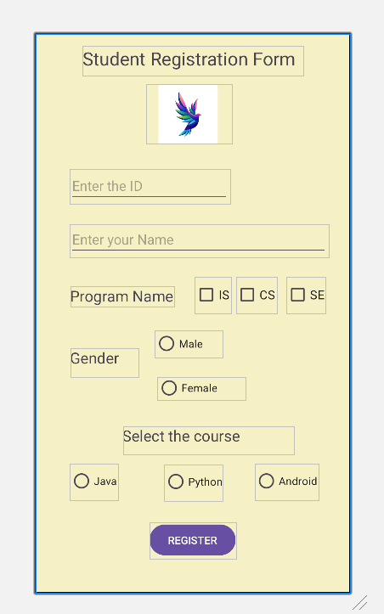

Use the following image for logo :



Upload the word file with the activity design.
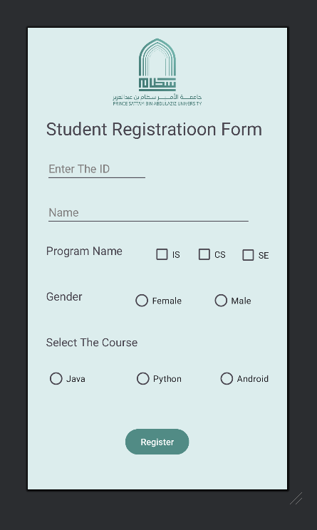

Coad bellow
<?xml version="1.0" encoding="utf-8"?>
<androidx.constraintlayout.widget.ConstraintLayout xmlns:android="http://schemas.android.com/apk/res/android"
xmlns:app="http://schemas.android.com/apk/res-auto"
xmlns:tools="http://schemas.android.com/tools"
android:id="@+id/main"
android:layout_width="match_parent"
android:layout_height="match_parent"
android:background="#DCEDED"
tools:context=".MainActivity">

<TextView
android:layout_width="wrap_content"
android:layout_height="wrap_content"
android:text="Student Registratioon Form"
android:textSize="28sp"
app:layout_constraintBottom_toBottomOf="parent"
app:layout_constraintEnd_toEndOf="parent"
app:layout_constraintHorizontal_bias="0.426"
app:layout_constraintStart_toStartOf="parent"
app:layout_constraintTop_toTopOf="parent"
app:layout_constraintVertical_bias="0.202" />

<EditText
android:id="@+id/editTextText"
android:layout_width="161dp"
android:layout_height="39dp"
android:ems="10"
android:inputType="text"
android:text="Enter The ID"
android:textColor="#807E7E"
tools:layout_editor_absoluteX="29dp"
tools:layout_editor_absoluteY="207dp" />

<CheckBox
android:id="@+id/checkBox"
android:layout_width="wrap_content"
android:layout_height="wrap_content"
android:text="CS"
tools:layout_editor_absoluteX="264dp"
tools:layout_editor_absoluteY="335dp" />

<RadioButton
android:id="@+id/radioButton"
android:layout_width="wrap_content"
android:layout_height="wrap_content"
android:text="Java"
tools:layout_editor_absoluteX="29dp"
tools:layout_editor_absoluteY="532dp" />

<RadioButton
android:id="@+id/radioButton"
android:layout_width="wrap_content"
android:layout_height="wrap_content"
android:text="Android"
tools:layout_editor_absoluteX="300dp"
tools:layout_editor_absoluteY="532dp" />

<RadioButton
android:id="@+id/radioButton"
android:layout_width="wrap_content"
android:layout_height="wrap_content"
android:text="Python"
tools:layout_editor_absoluteX="167dp"
tools:layout_editor_absoluteY="532dp" />

<TextView
android:id="@+id/textView"
android:layout_width="142dp"
android:layout_height="49dp"
android:text="Program Name"
android:textSize="18sp"
tools:layout_editor_absoluteX="29dp"
tools:layout_editor_absoluteY="341dp" />

<CheckBox
android:id="@+id/checkBox"
android:layout_width="wrap_content"
android:layout_height="wrap_content"
android:text="SE"
tools:layout_editor_absoluteX="334dp"
tools:layout_editor_absoluteY="336dp" />

<RadioButton
android:id="@+id/radioButton"
android:layout_width="wrap_content"
android:layout_height="wrap_content"
android:text="Female"
tools:layout_editor_absoluteX="165dp"
tools:layout_editor_absoluteY="408dp" />

<RadioButton
android:id="@+id/radioButton2"
android:layout_width="wrap_content"
android:layout_height="wrap_content"
android:text="Male"
tools:layout_editor_absoluteX="291dp"
tools:layout_editor_absoluteY="408dp" />

<EditText
android:id="@+id/editTextText"
android:layout_width="325dp"
android:layout_height="45dp"
android:ems="10"
android:inputType="text"
android:text="Name"
android:textColor="#807E7E"
android:textColorLink="#434343"
tools:layout_editor_absoluteX="29dp"
tools:layout_editor_absoluteY="270dp" />

<TextView
android:id="@+id/textView"
android:layout_width="156dp"
android:layout_height="53dp"
android:text="Select The Course"
android:textSize="18sp"
tools:layout_editor_absoluteX="29dp"
tools:layout_editor_absoluteY="486dp" />

<CheckBox
android:id="@+id/checkBox"
android:layout_width="wrap_content"
android:layout_height="wrap_content"
android:text="IS"
android:textSize="14sp"
tools:layout_editor_absoluteX="197dp"
tools:layout_editor_absoluteY="335dp" />

<TextView
android:id="@+id/textView"
android:layout_width="85dp"
android:layout_height="43dp"
android:text="Gender"
android:textSize="18sp"
tools:layout_editor_absoluteX="29dp"
tools:layout_editor_absoluteY="413dp" />

<Button
android:id="@+id/button3"
android:layout_width="wrap_content"
android:layout_height="wrap_content"
android:layout_marginTop="644dp"
android:backgroundTint="#518B85"
android:text="Register"
app:layout_constraintTop_toTopOf="parent"
tools:layout_editor_absoluteX="140dp" />

<ImageView
android:id="@+id/imageView"
android:layout_width="149dp"
android:layout_height="156dp"
app:srcCompat="@drawable/_______1_"
tools:layout_editor_absoluteX="127dp"
tools:layout_editor_absoluteY="-18dp" />

</androidx.constraintlayout.widget.ConstraintLayout>

